Lab04 Data Analysis (Pandas)

1. **Basic data filtering with pokemon (20 points, 5 points each question)**

Let’s start with the basic of pandas.

1. Data filtering (5 points)
   1. What is the strongest pokemon in generation 1? (1 points)
   2. How many pokemons exist with speed greater than 100? (2 points)
   3. Plot the Attack to Defense scatter plot. And answer which pokemon is the outlier at the lower right corner? (2 points)

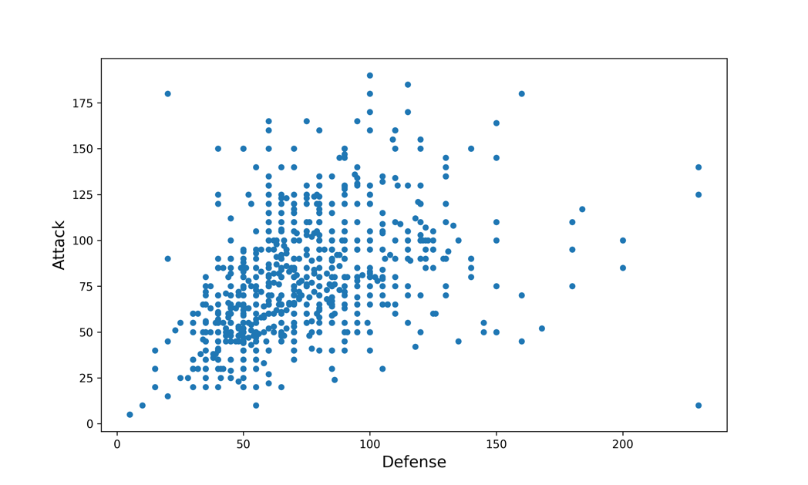

1. Plot the distribution of pokemon’s types with a pie chart. (5 points)

Output should be like:

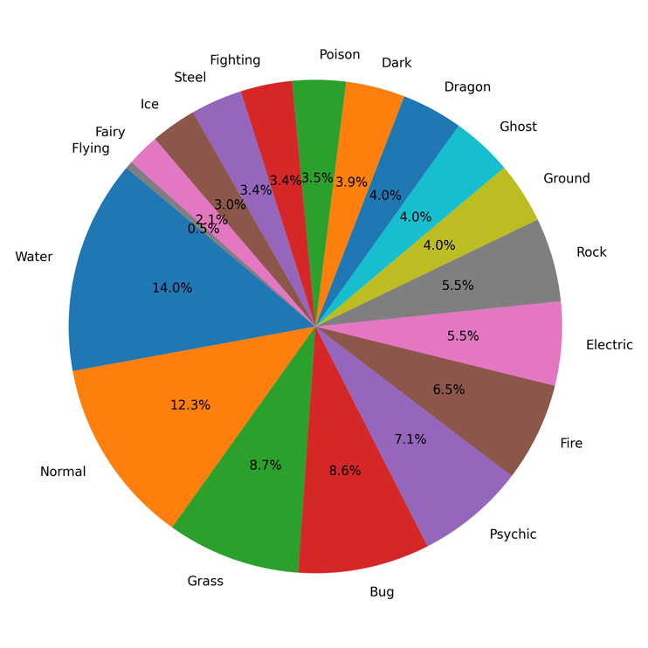

1. Average attack value in different type (5 points)

Output should be like:

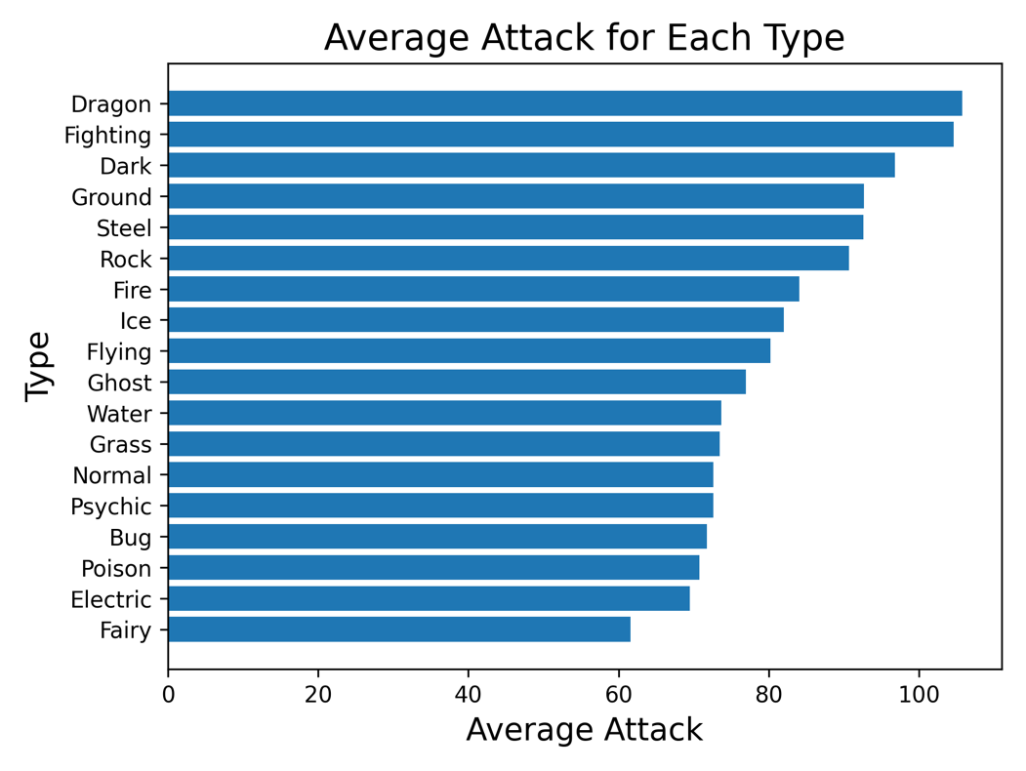

1. Plot the sum of all state in different generations and describe what you found. (5 points)

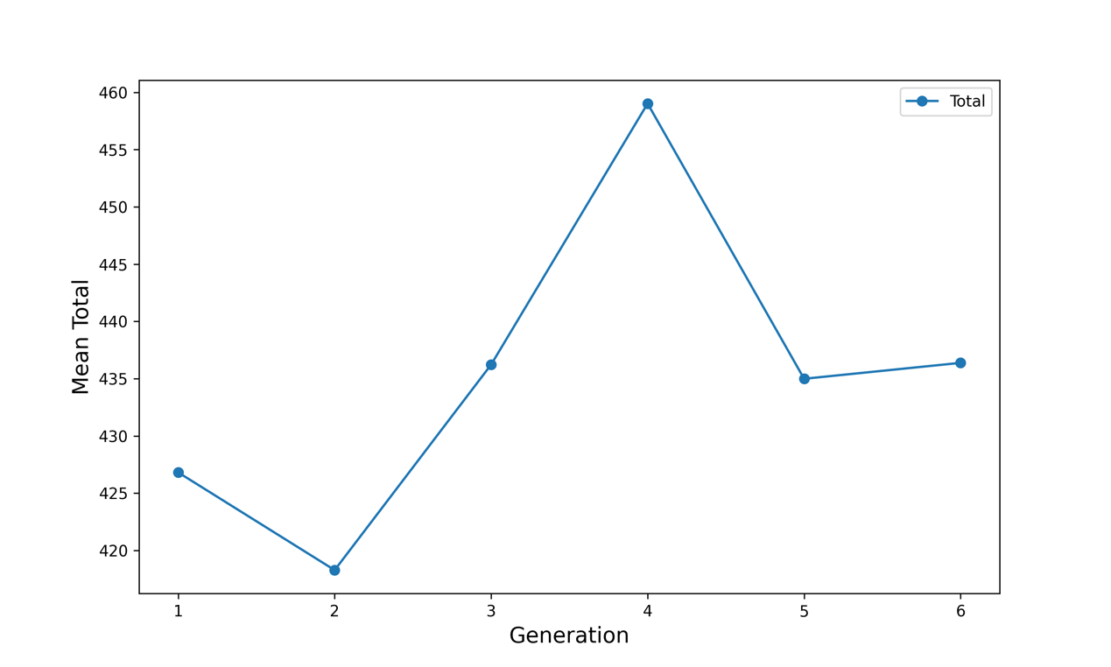

1. **Data analysis with NBA player in 2022-2023 (20 points, 10 points each question)**
2. 先畫出nba球員的平均身高與平均體重的柱狀分佈圖，其中需使用紅色直線在圖中分別顯示美國男子的平均身高與平均體重。

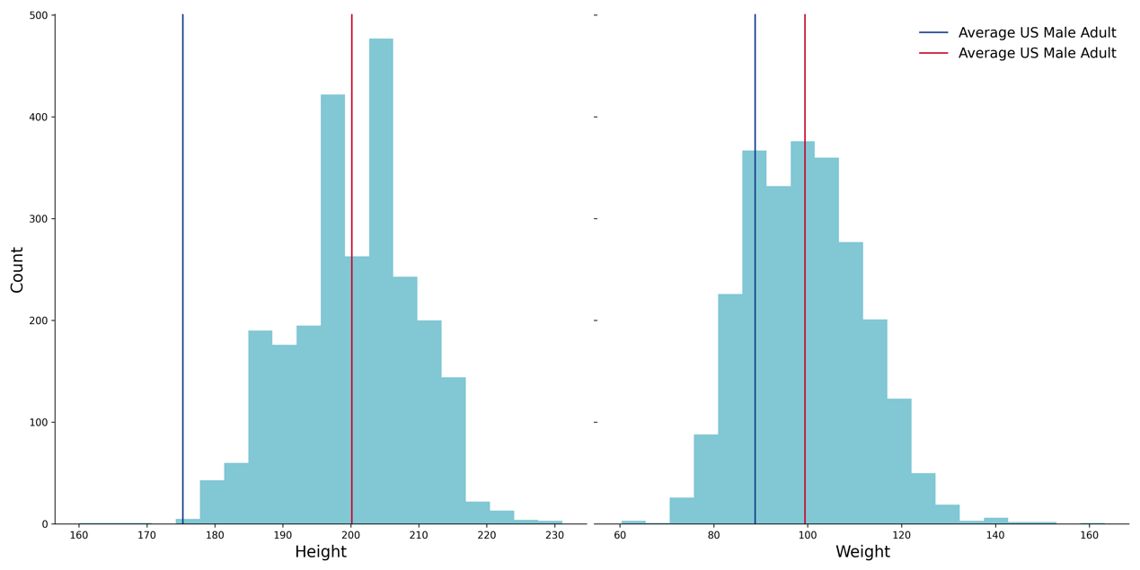

1. 由於小球戰術興起，因此我們好奇是否真的在2000以後，聯盟球員的身高比2000前還矮上許多。

利用折線圖畫出每隊球員的身高體重隨時間變化圖。

